1. **What is Node and how to install Node ?**

* Node.js’ package ecosystem, [npm](https://www.npmjs.com/" \t "_blank), is the largest ecosystem of open source libraries in the world.
* Node is lightweight open source.
* Node is a runtime environment includes everything you need to execute a program written in JavaScript.
* JavaScript and Node.js run on the V8 JavaScript runtime engine. This engine takes your JavaScript code and converts it into a faster machine code.

**Installation of node in system**

* So basically the installation process is depends on user Operating system
* If user have windows then user need to download nodejs from the official site. link <https://nodejs.org/>
* After download double click on exe file.
* One prompt will appear read the instruction and click on next…go on until finish
* Node will be installed successfully in system.

1. Difference between NVM and NPM ?

* NPM stands for node pakage manager it is a tool that allows you to install javascript packages
* We can check a version using command npm –v, node -v after installation
* Npm is a package manager which holds one version we cannot switch our node versions
* To install NPM =>go to <https://nodejs.org/> download latest version of LTS node and install in system with this node npm automatically gets installed.

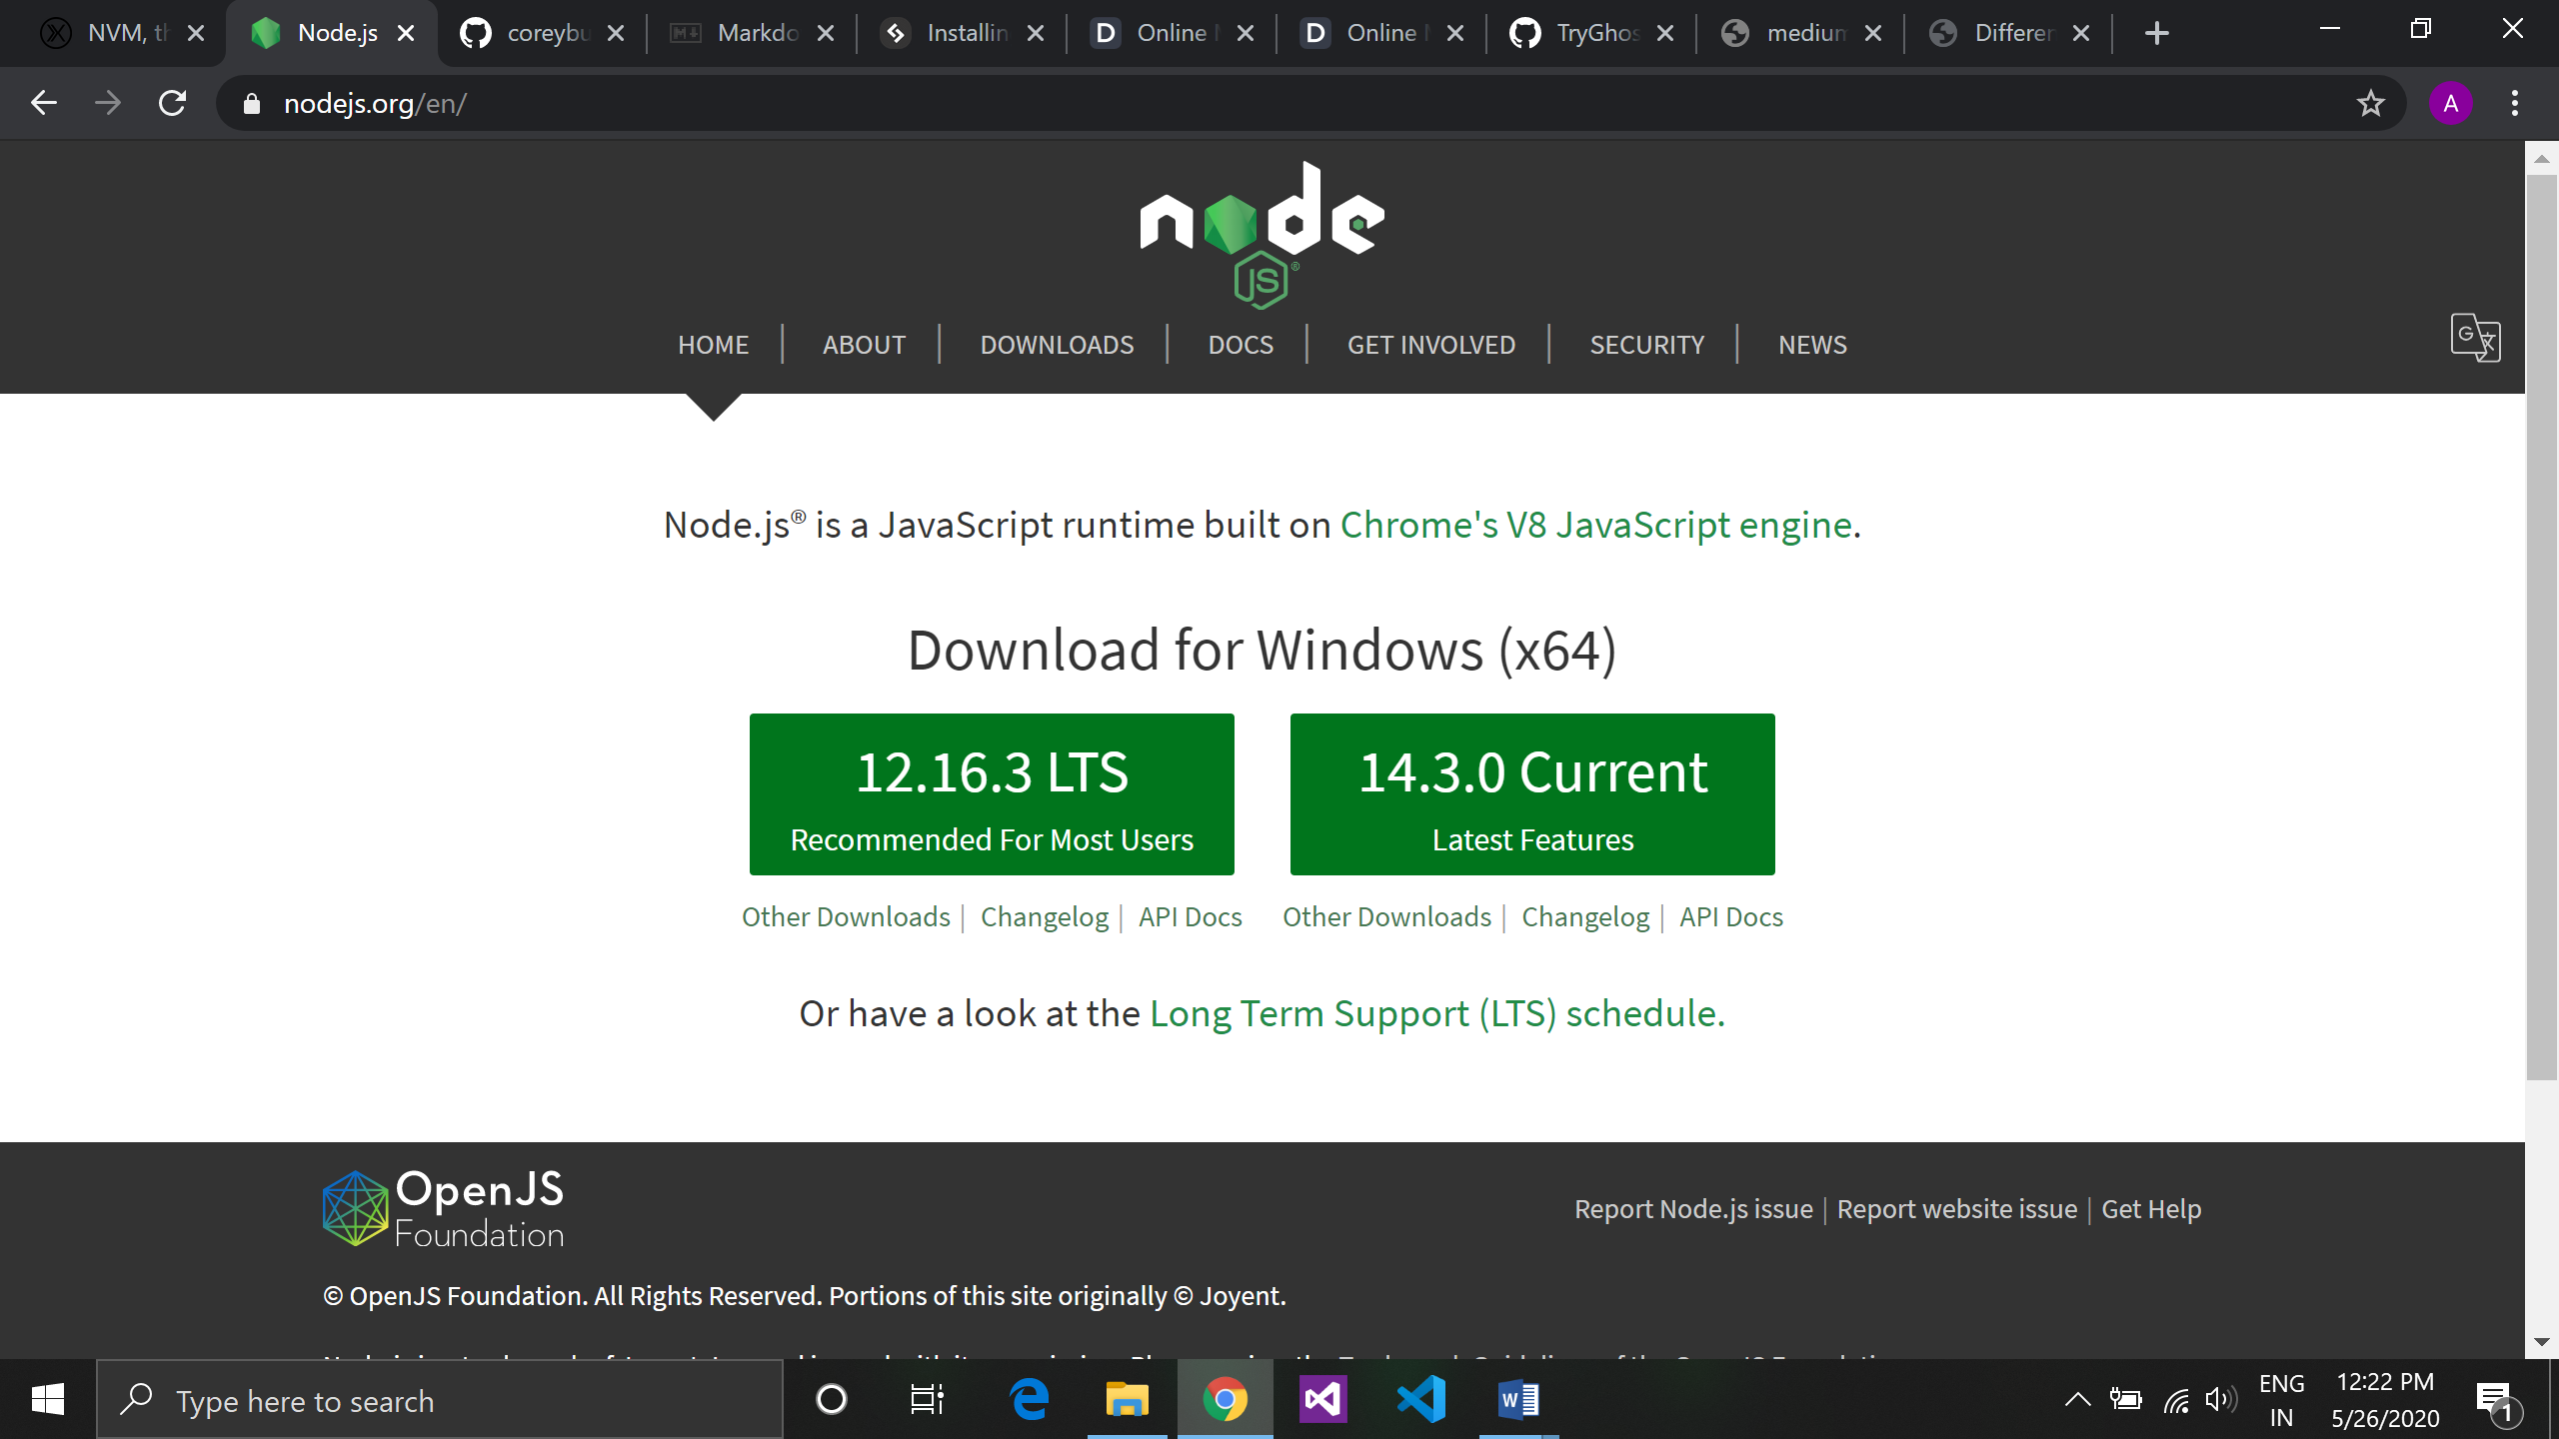

* NVM stands for node version manager it is a tool that allows you to install and download nodejs.
* We can check a version using command nvm –v, node –v after installation
* Nvm is used to keep multiple versions of nodejs and work with different versions at a time.
* To switch version Command => nvm use <version\_name>

1. How do we use NPM ? What is the meaning of -g in npm install?

NPM is a node package manager which is a world largest library

**Node.js makes it possible to write applications in JavaScript on the server.**

* + **To check installed version of node**

$ which node

/usr/bin/node

$ node --version

v12.15.0

* + To check installed version of NPM

$ which npm

/usr/bin/npm

$ npm --version

6.13.7

* + Updating npm

npm install -g npm@latest

* + Install local package.

**npm** i <package>

* + Install global package

**npm** i -g <package>

* + uninstall local package.

**npm** un <package>

1. **What is Semantic Versioning in software development?**

Semantic versioning is defined the versions of software and there updation bug fixing report.

Version: 1.0.0

Semantic versioning is classified in 3 phases

* + Major : first digit
  + Minor : second digit
  + Patch : third digit
  + If major digit changed it means it is a major change in software the new features break backwards compatibility.
    - * Version: 1.x.x
  + If minor digit changed it don’t break existing feature it may not affected on major number.
    - * version :1.1.x
  + If there is some report on software that means it is bug, when developer fixed this bug the last digit of versioning get increment by one.
    - * Version:1.1.1

**5. What is Markdown ? Write atleast 6 Markdown commands with their meaning.**

* Markdown is a lightweight markup language based on the formatting conventions that people naturally use in email.
* It is a lightweight markup language with plain text formatting syntax.
* Markdown can be used for everything. People use it to create [websites](https://www.markdownguide.org/getting-started/#websites), [documents](https://www.markdownguide.org/getting-started/#documents), [notes](https://www.markdownguide.org/getting-started/#notes), [books](https://www.markdownguide.org/getting-started/#books), [presentations](https://www.markdownguide.org/getting-started/#presentations), [email messages](https://www.markdownguide.org/getting-started/#email), and [technical documentation](https://www.markdownguide.org/getting-started/#documentation).
* Markdown is portable.
* Markdown is platform independent. You can create Markdown-formatted text on any device running any operating system.

| **Element** | **Markdown Syntax** |
| --- | --- |
| [Heading](https://www.markdownguide.org/basic-syntax/#headings) | # H1 ## H2 ### H3 |
| [Bold](https://www.markdownguide.org/basic-syntax/#bold) | \*\*bold text\*\* |
| [Italic](https://www.markdownguide.org/basic-syntax/#italic) | \*italicized text\* |
| [Blockquote](https://www.markdownguide.org/basic-syntax/#blockquotes-1) | > blockquote |
| [Ordered List](https://www.markdownguide.org/basic-syntax/#ordered-lists) | 1. First item 2. Second item 3. Third item |
| [Unordered List](https://www.markdownguide.org/basic-syntax/#unordered-lists) | - First item - Second item - Third item |
| [Code](https://www.markdownguide.org/basic-syntax/#code) | `code` |
| [Horizontal Rule](https://www.markdownguide.org/basic-syntax/#horizontal-rules) | --- |
| [Link](https://www.markdownguide.org/basic-syntax/#links) | [title](https://www.example.com) |
| [Image](https://www.markdownguide.org/basic-syntax/#images-1) | ![alt text](image.jpg) |

6. Create a sample express application and run it and take a screenshot and submit.

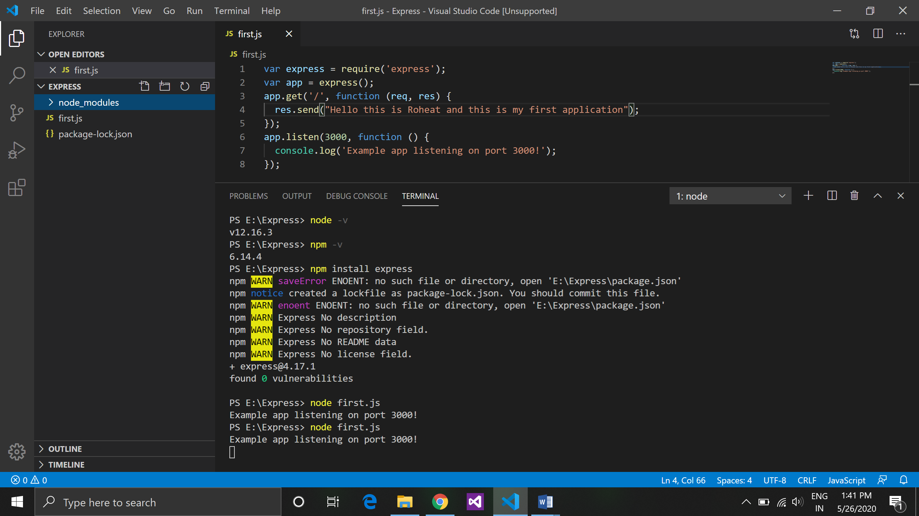

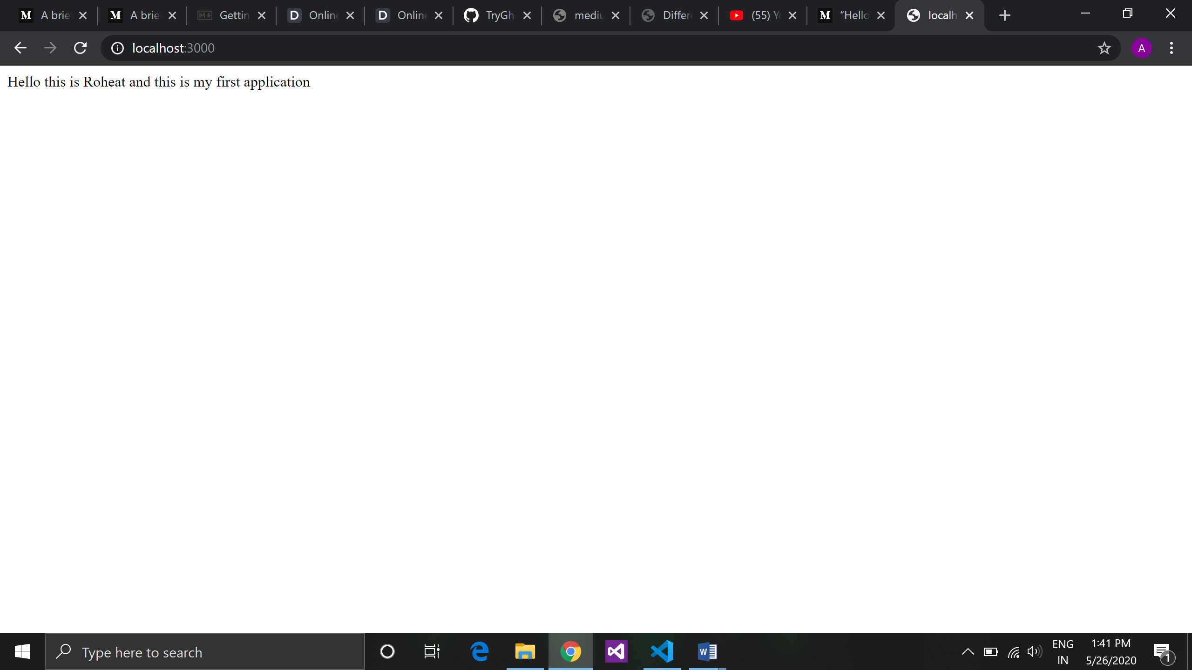

| **Element** | **Markdown Syntax** |
| --- | --- |
| [Heading](https://www.markdownguide.org/basic-syntax/#headings) | # H1 ## H2 ### H3 |
| [Bold](https://www.markdownguide.org/basic-syntax/#bold) | \*\*bold text\*\* |
| [Italic](https://www.markdownguide.org/basic-syntax/#italic) | \*italicized text\* |
| [Blockquote](https://www.markdownguide.org/basic-syntax/#blockquotes-1) | > blockquote |
| [Ordered List](https://www.markdownguide.org/basic-syntax/#ordered-lists) | 1. First item 2. Second item 3. Third item |
| [Unordered List](https://www.markdownguide.org/basic-syntax/#unordered-lists) | - First item - Second item - Third item |
| [Code](https://www.markdownguide.org/basic-syntax/#code) | `code` |
| [Horizontal Rule](https://www.markdownguide.org/basic-syntax/#horizontal-rules) | --- |
| [Link](https://www.markdownguide.org/basic-syntax/#links) | [title](https://www.example.com) |
| [Image](https://www.markdownguide.org/basic-syntax/#images-1) | ![alt text](image.jpg) |